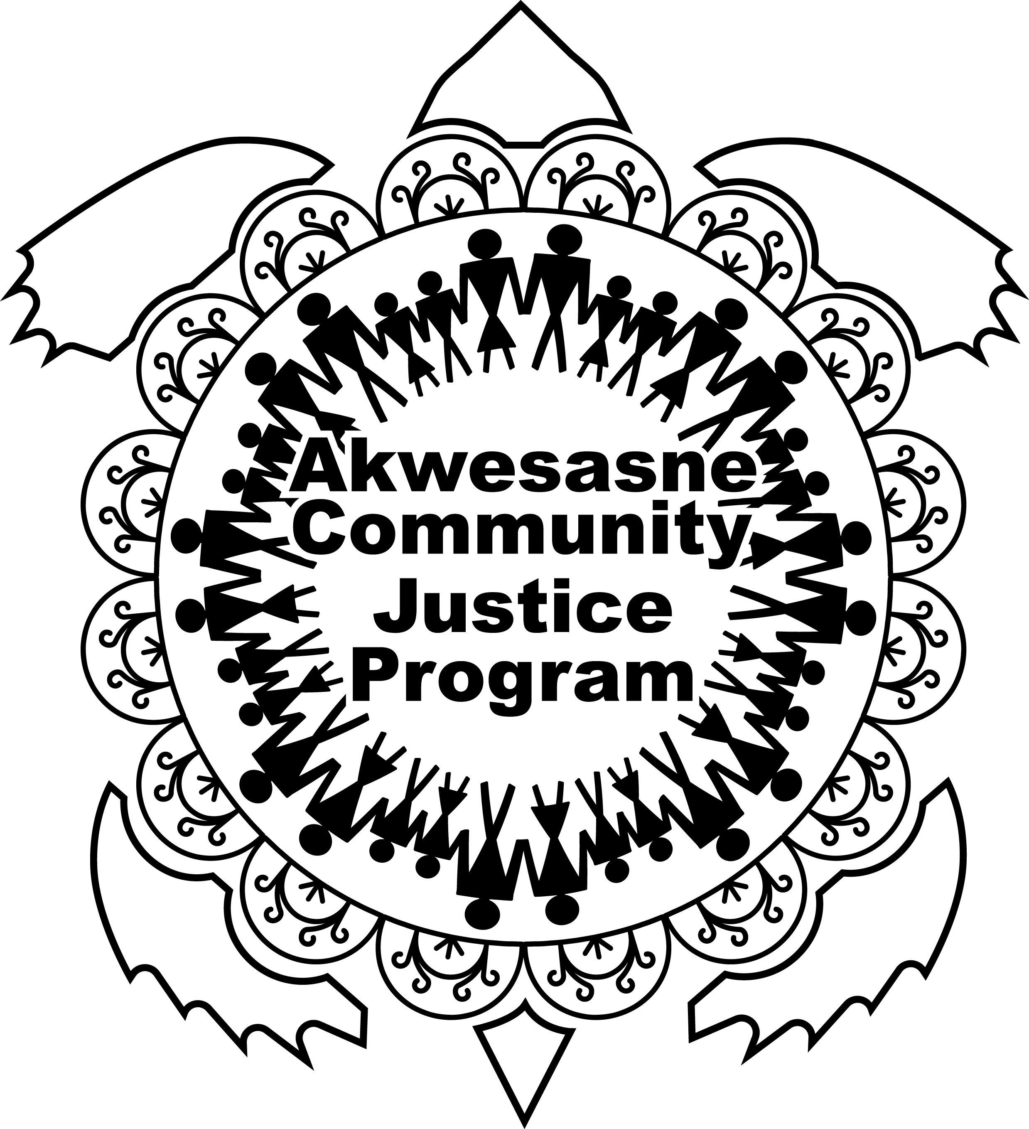
Akwesasne Community Justice Program
Ietsiiatahónhsatat Victim Services
Client Intake Form

Date of Intake: ______________________ Location of Intake: ________________________
Referred by: Health Organization Police Agency V/WAP CAVAC
Shelter Self-referral ACJP Other: ___________________
Read the following to the victim:
The following information will remain confidential and will only be disclosed to outside agencies if permission to do so is given by you, as the victim. If there is a question that you do not want to disclose the answer to, you have the right whether or not to do so. The questions are tailored to help us provide the best services suited for you and your needs, as well as to help improve future services for others who have been victimized. If at any point this intake gets to be overwhelming for you to handle, please inform the Victim Support Worker. The Victim Support Worker will then stop the intake, and listen to your thoughts and concerns.

Personal Information
First Name: _______________________________ MI: ________ DOB: ______________
Last Name: _______________________________
Gender: Female Male Other Pronouns: Her/She His/Him Them/They
Relationship Status: Single Common Law Married Divorced
Widowed Separated
Number of Dependent Children: 0 1 2 3 4+
Address: __________________________________________________________________________
Phone Number: ____________________________ Email: ___________________________________
Preferred method of contact: Call Text Email Call Blocking Necessary: YES / NO
Details of Victimization
Primary Victim Secondary Victim Witness Other Multiple Offenders? YES / NO
Accused’s Name #1: _____________________________________________ Male / Female / Other
If known, the relationship and length of time you have known the accused: _________________________
Accused’s Name #2: _____________________________________________ Male / Female / Other
If known, the relationship and length of time you have known the accused: _________________________
Accused’s Name #3: _____________________________________________ Male / Female / Other
If known, the relationship and length of time you have known the accused: _________________________
Has the victimization been reported to a law enforcement agency? YES / NO
If yes, to what law enforcement agency? ______________________________________________
If no, do you plan on reporting? YES / NO
Date and Time of Incident: ___________________________ Location: ____________________________
Case Type: Abduction Assault (D.V) Assault (All Other) Criminal Harassment
Elder Abuse Human Trafficking M.V.A. Sexual Assault
Tragic Circumstance Other: _____________________________________________
Charges: _____________________________________________________________________________
_____________________________________________________________________________________
Personal Injuries to Victim: _______________________________________________________________
_____________________________________________________________________________________
Property Damage: ______________________________________________________________________
_____________________________________________________________________________________
Has the victimization, affected areas of your everyday life? YES / NO
If yes, list: _______________________________________________________________________
Do you have people that you can turn to for support? YES / NO
If yes, list: _______________________________________________________________________
In the case that the Victim was not referred by V/WAP, read the following:
Do you fear the accused/fear for your life? YES / NO
Does the offender have a key to your home? YES / NO
Do you require lock changes? YES / NO
Do you have children with the accused? YES / NO
Does the accused have mental health issues that you know of? YES / NO
Does the accused have a substance abuse issue that you know of? YES / NO
Does the accused have aboriginal status that you know of? YES / NO
Does the accused have any of your possessions, or vice versa? YES / NO
Do you require authorities to attend during the return of possessions? YES / NO
Would you like to be notified when the accused is released? YES / NO
Drug/Alcohol History
Do you currently use alcohol or drugs? YES / NO
Describe the use of drugs and alcohol (i.e. type, amount, frequency):
___________________________________________________________________________________
When did you start using alcohol and/or drugs? ____________________________________________
Do you believe that your victimization has worsened your alcohol and/or drug use? YES / NO
Do you believe your alcohol and/or drug use to be a problem? YES / NO
Mental Health History
Have you attended counseling previously? YES / NO
Are you currently in therapy or counseling with anyone? YES / NO
Have you ever been diagnosed with a mental illness? YES / NO
If yes, what was your diagnosis: ___________________________________________________
Have you ever been hospitalized for any mental health reasons? YES / NO
Are you currently taking any psychotropic medications? YES / NO
Have you ever attempted suicide? YES / NO
Have you recently had thoughts of suicide? YES / NO
Have you ever participated in self-harm behaviors? YES / NO
Trauma History
Have you ever been physically, emotionally, mentally or sexually abused? YES / NO
Have you experienced the death of a very close friend or family member? YES / NO
As a child, was a household member incarcerated? YES / NO
As a child, have you ever been taken out of the home by child protective services? YES / NO
Neh-Kanikonriio Council
What would you like to get out of the hearing? ______________________________________________
___________________________________________________________________________________
___________________________________________________________________________________
Is there anyone that you would like to attend the hearing? __________________________________
___________________________________________________________________________________
Is there anything else that you feel we should know regarding this incident? _________________________
___________________________________________________________________________________
___________________________________________________________________________________

Services Requested: (check and then circle specific service, if applicable)
Accompaniment to court
Advocacy
Assistance/Prepare/Information on pre and post stages of the diversion and old ways conferencing
Assistance with appropriate community resources
Court Preparation/Court Debriefing
Information on Investigative Processes/Court Processes
Information on Victim’s Rights
Counselling with Elders or Traditional People
Land-based/Traditional Healing Activities/Traditional Healing Services
Safety Planning/Protection Measures
Help with financial benefits/restitution

Referrals Made to:
Hospital
Legal Organization
Counselling
Treatment Programs
Shelter
Other: ____________________________________________________________________________

NOTES

